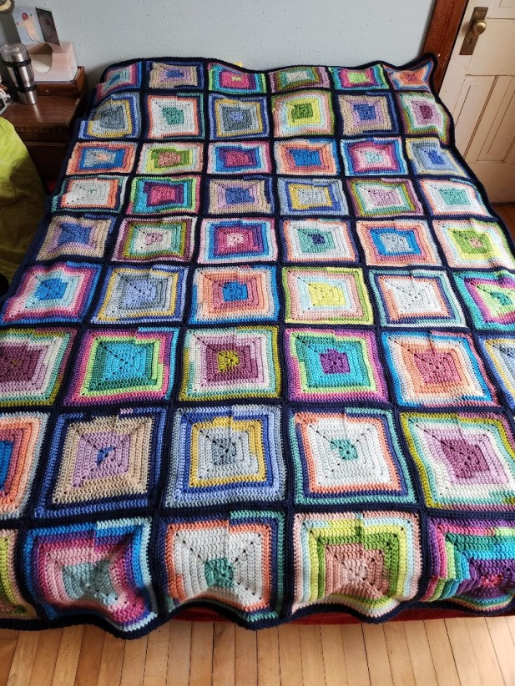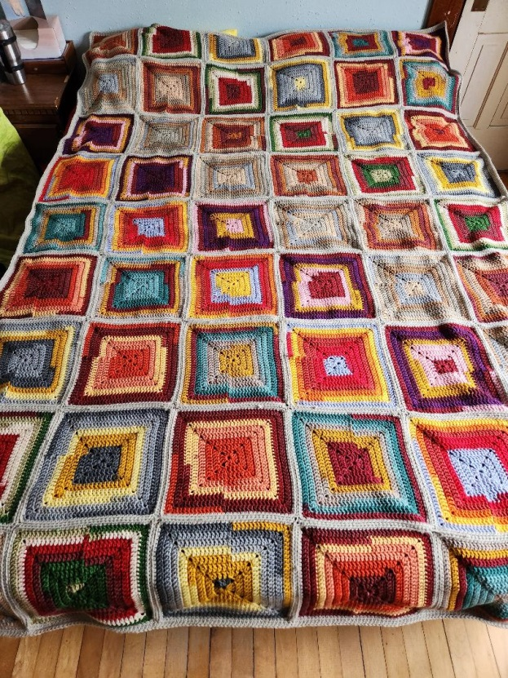
# 1 60” x 85” # 2 60” X 85”
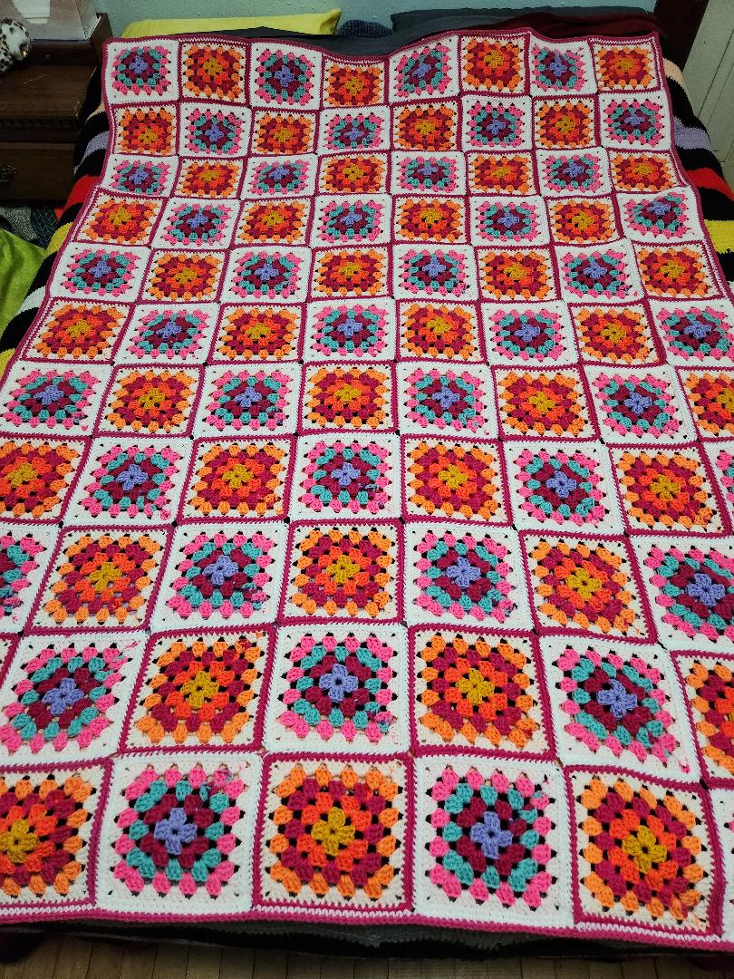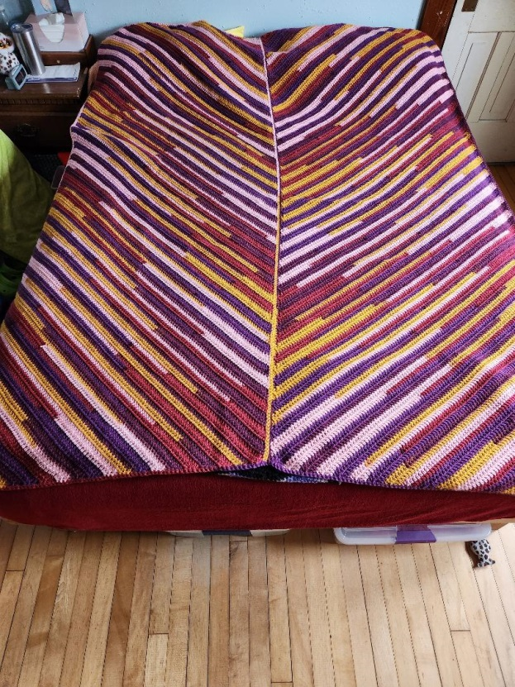
# 3 55” x 80” # 4 60” x 85”
Afghans for sale, $100.00 each. Proceeds from the sales will go to the Trinity School scholarship fund.
Contact the school or church office to purchase the afghans.

