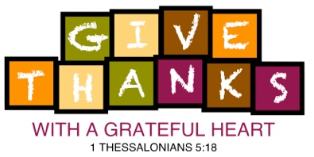

June 3, 2019

Trinity Lutheran School
819 School Avenue
Oshkosh, WI 54901
Phone No. (920) 235-1730
Email: auction@trinityoshkosh.org

To Whom it May Concern,

I am writing to you on behalf of Trinity Lutheran School to request your support of our 2019 auction: Give Thanks with a Grateful Heart, a very special event to raise money for new curriculum software and technology hardware. The auction will be held on Saturday, November 2, 2019 at LaSure’s Banquet Hall in Oshkosh.

The Give Thanks with a Grateful Heart auction will support education and technology enhancements for the students at Trinity. Trinity Lutheran is a K-8 school that has been offering quality Christian education to the Oshkosh community since 1856. Trinity educates children and helps develop strong Christian character to lead lives of leadership and service throughout our community.

Last year’s event was a tremendous success with nearly 100 guests attending and raising over $18,500 for our school. Would you be willing to step alongside us to meet our 2019 goal of 125 guests and $25,000?

We hope you will join us in supporting our cause through a donation for our silent and live auctions such as: merchandise, products, gift cards/certificates, tickets, handmade items, etc. These would be a wonderful addition to the event and would certainly enhance the dollars that are raised.

In return for your donation, we would like to offer the following promotional consideration:

- Auction Catalog and Item Signage
- On Facebook page (https://www.facebook.com/TrinityOshkoshAuction)

If you are interested in participating, please complete the enclosed procurement form and return it via email at auction@trinityoshkosh.org or by fax at 920-235-1734 by September 1st. Please keep a copy of the form as a receipt for your records.

Thank you very much for your consideration of our request. Please feel free to contact Jay at 920-540-2769, Shelly at 920-420-7138 or email us at auction@trinityoshkosh.org if I can be of assistance.

Sincerely,
Jay Schultz/Shelly Rothe
Trinity Lutheran Auction Committee Members
https://www.trinitylutheranschooloshkosh.org/auction

