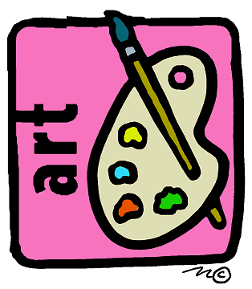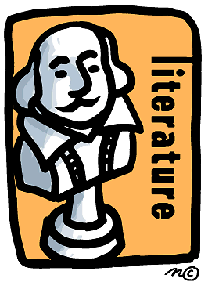

Art and Literature Fair

Wednesday, April 17th

5:30 p.m. – 7:00 p.m.

We will also have a Chili Competition at the Art and Literature Fair. Bring a pot of your favorite chili recipe to be judged and to share. The winner will receive the coveted “Golden Spoon” Award. Hot dogs will also be served. Please note below if you can bring chili, and/or dessert bars!

*************************************************************************************

Please turn this form in to the office by Monday, April 15th.

Family name _____________________________________

How many will attend the Art and Literature Fair? _______________

Please mark what you can do to help for this event:

Large crockpot of chili _________ Do you want to be entered into the Chili Competition? __________

One dozen dessert bars or cookies _________

Set up and serve from 5:00 – 6:00 (4-5 volunteers) ________

Serve and clean up from 6:00 – 7:00 (4-5 volunteers) ________

